**BIBLIOMETRICS**

*The statistical analyses of books, articles or other publications. The analyses are used to track author or researcher output and impact. This can help in promotion and tenure, as well as aiding in funding and grants.*

* A bibliometric provides evidence of the impact of your research outputs when applying for jobs, promotion or research funding
* Contribute to TUT’s recognition and status
* Find new and emerging areas of research
* Identify potential research collaborators
* Identify journals in which to publish

***WHERE YOU SHOULD START TO BUILD YOUR RESEARCHER BIBLIOMETRICS PROFILE***

* Scopus and orcid
* Google scholar
* Web of science and orcid
* ResearchGate

Example of scopus and orcid

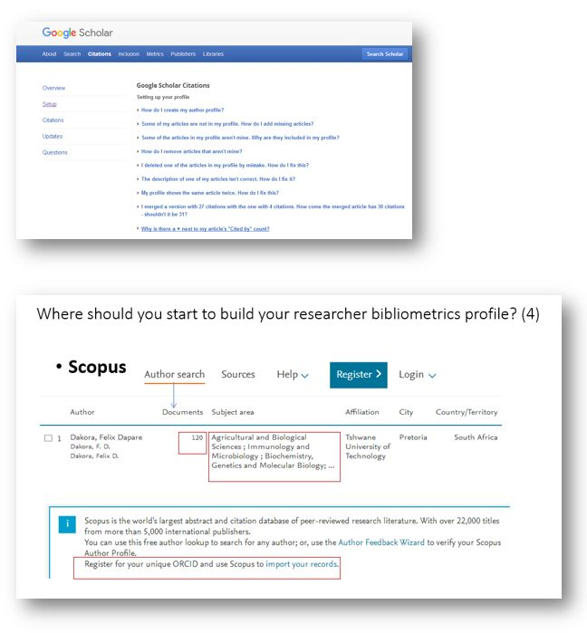

Example of ResearchGate

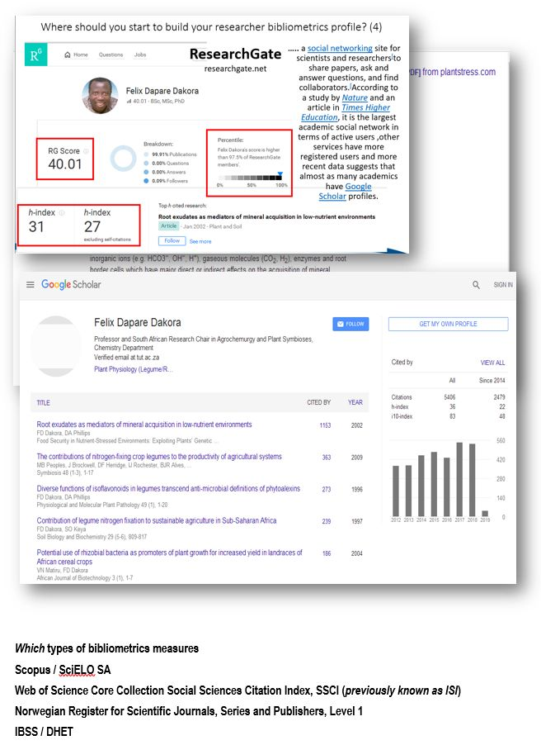

**PROBLEM STATEMENT**

Writing a problem statement can be a problem if you don’t know what one is. Knowing how to write one involves knowing what it is not:

* not a topic
* not a vague proposition
* not an explanation of how to do something

And knowing what it should be. A problem statement identifies:

* an issue
* a controversy a problem
* a problem, controversy or issue’s significance
* a specific purpose research questions/hypotheses
* a framework for reporting – provides a way to answer the “so what” question

A written problem statement is one to two sentences describing a situation that is in need of more information on a problem which needs further study. The well written problem statement will propose a method for collection of the needed data on the problem to gain evidence or to add to what is already known about it. When correctly written, a problem statement should:

* include a question relating to background research
* clearly state what will be investigated
* include a way to collect data
* clearly state what and how measurement will occur
* identify a sample group
* use correct grammar
* not imply or point fingers at any specific cause or solution

To be successful in writing your problem statement, remember:

* you are writing to a professional, business oriented audience/reader
* to use objective language – consider the problem as an observer without an emotional connection to it
* to use language which will help you understand how to do what you plan to do
* to explain to the audience/reader how you became aware of the problem and its importance – affects on others, the workplace, the company

Example of a problem statement

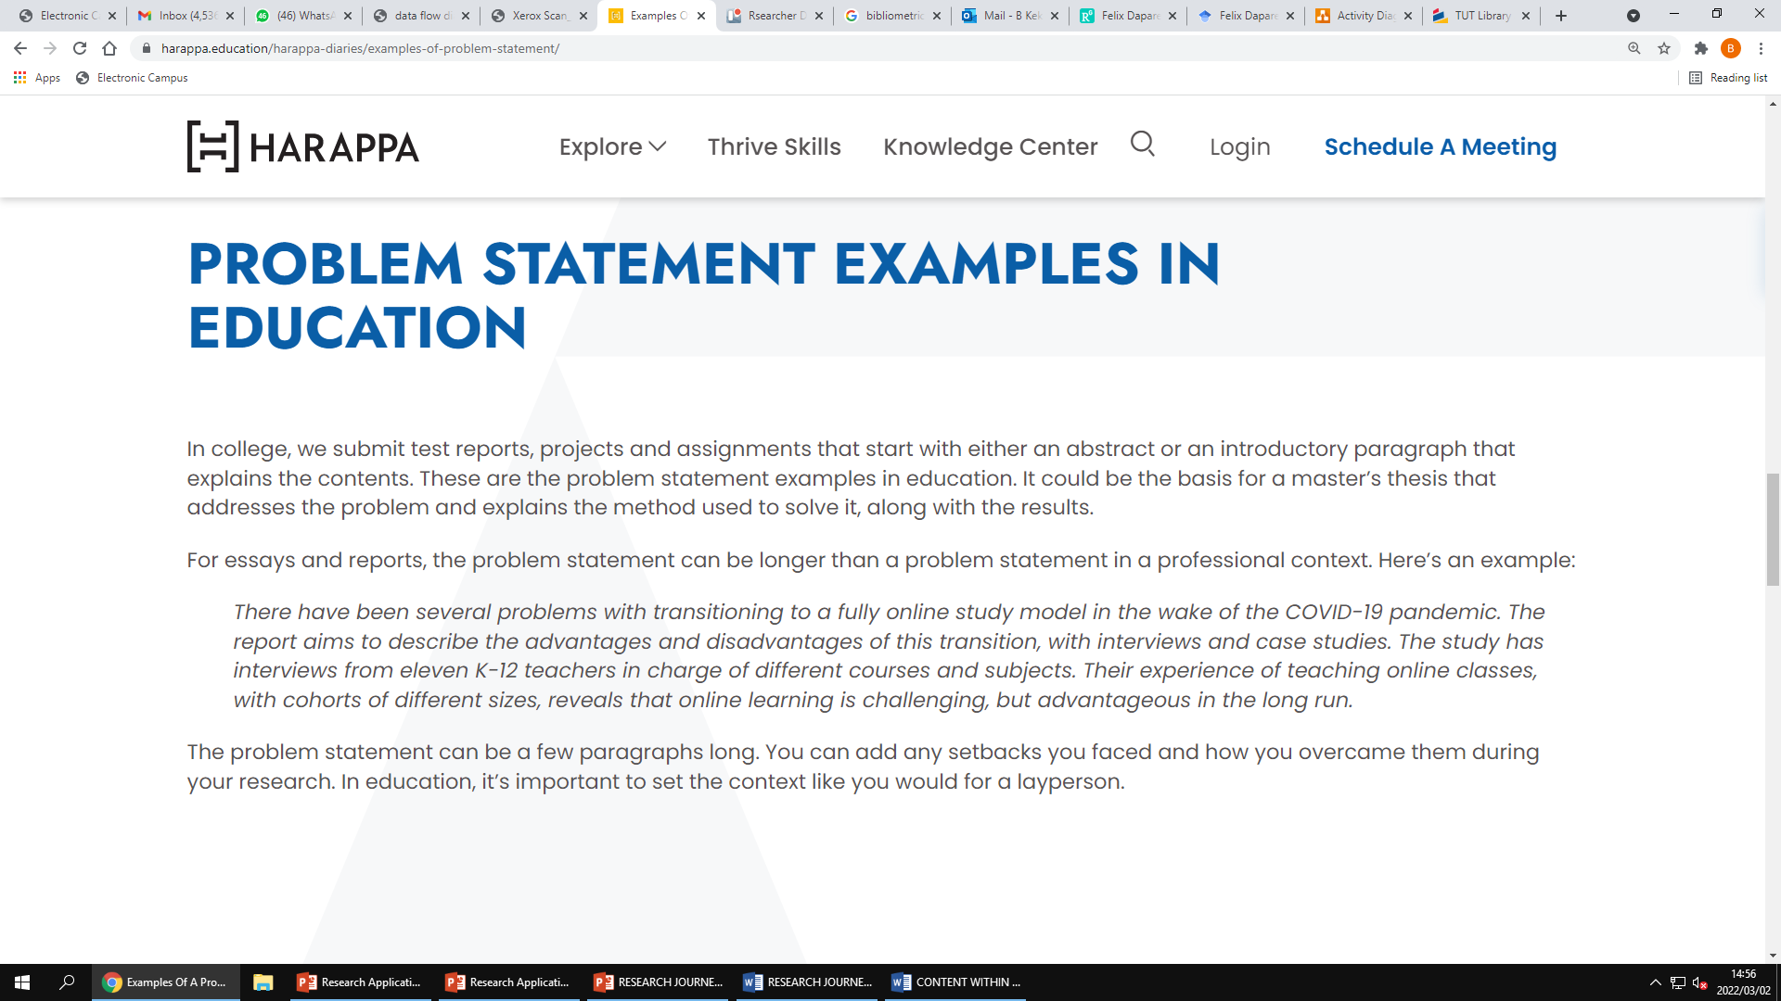

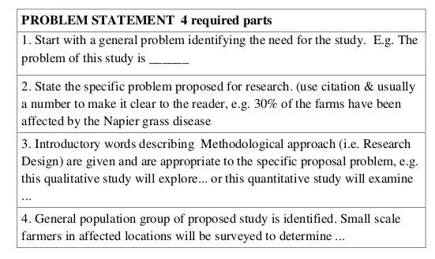

**The topic**

* Get an understanding of the basic research concept
  + Research problems
  + Research questions
  + Literature review
  + Methodologies
  + Fieldwork methods
* Review previous dissertations from your university(rules you will need to know)
  + Originality – how unique does your topic need to be
  + Topic restrictions – which topics are allowed
  + Data requirements – primary, secondary, or both
  + Methodology – qualitative, quantitative, mixed
  + Ethics – what are the restrictions and requirements
* Review the academic literature to start the ideation process
* Identify your potential research questions and shortlist
* Narrow it down ,then evaluate your research topic shortlist
* Make the decision

How to choose a research topic for a dissertation or thesis. Simple steps plus examples.

<https://youtu.be/hXvoKE6_wQo>

**RESEARCH QUESTIONS**

* **Aim:**To describe the development of a research question, aim and objective.
* **Background:**The first steps of any study are developing the research question, aim and objective. Subsequent steps develop from these and they govern the researchers' choice of population, setting, data to be collected and time period for the study. Clear, succinctly posed research questions, aims and objectives are essential if studies are to be successful.
* **Discussion:**Researchers developing their research questions, aims and objectives generally experience difficulties. They are often overwhelmed trying to convert what they see as a relevant issue from practice into research. This necessitates engaging with the relevant published literature and knowledgeable people.
* **Conclusion:**This paper identifies the issues to be considered when developing a research question, aim and objective. Understanding these considerations will enable researchers to effectively present their research question, aim and objective.
* **Implications for practice:**To conduct successful studies, researchers should develop clear research questions, aims and objectives.
* **Keywords:**novice researchers; nursing research; research aim; research objective; research question; study development.
* **Research objectives**
  + Your aims answer the question, ‘What are you doing?’ The **objectives are the answer to the question, ‘How are you doing it?’**
  + Research objectives refer to the goals or steps that you will take to achieve your aims.
  + When you write them, **make sure they are SMART.**

1. **S**pecific: talk in a precise and clear way about what you are going to do.
2. **M**easurable: how will you know when you have achieved your aim?
3. **A**chievable: make sure that you aren’t overly ambitious.
4. **R**ealistic: recognise the time and resource constraints that come with doing a PhD and don’t attempt to do too much.
5. **T**ime constrained: determine when each objective needs to be completed.

* You need to be as explicit as possible here. Leave the reader in no doubt about what you will do to achieve your aims. Step by step. Leave no ambiguity. At the same time, be careful not to repeat your methods chapter here. Just hint at your methods by presenting the headlines. You’ll have plenty of space in your methods discussion to flesh out the detail.
* Elsewhere in the thesis you will necessarily have to talk in a complex language and juggle complex ideas. Here you don’t. You can write in clear, plain sentences.

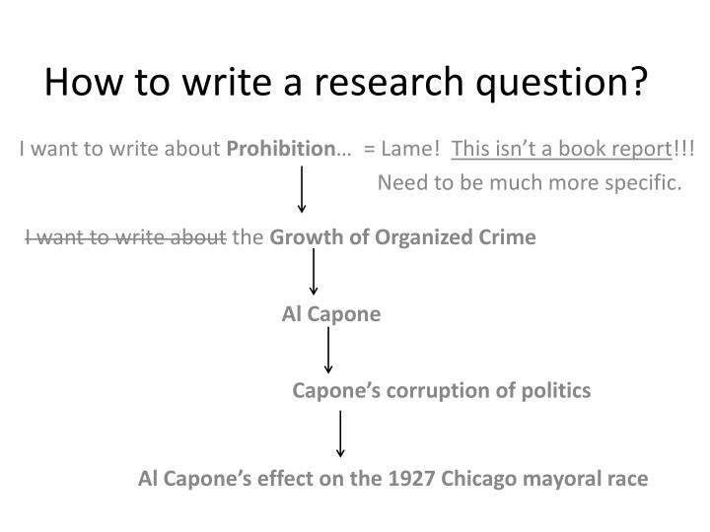



**LITERATURE REVIEW**

* Define and refine your topic
* Search all relevant sources systematically and effectively
* Find, evaluate and manage the information
* Synthesize the literature and integrate it into your writing

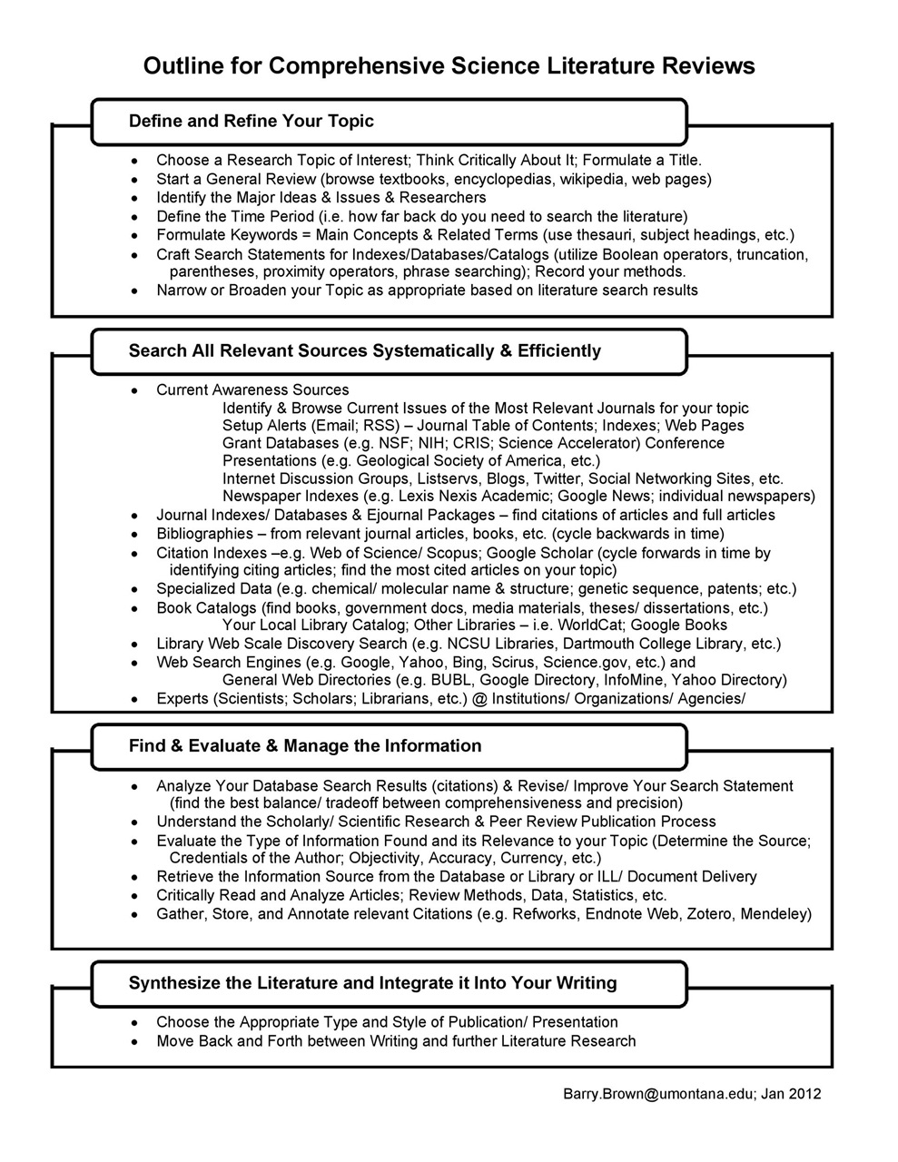

**RESEARCH DESIGN**

The research design refers to the overall strategy that you choose to integrate the different components of the study in a coherent and logical way, thereby, ensuring you will effectively address the research problem; it constitutes the blueprint for the collection, measurement, and analysis of data.

* 5 common research design types:
  + Descriptive research design
    - This is a theory-based design, where the researcher is primarily interested in describing the topic that is the subject of the research. It is applied to case studies, naturalistic observations, surveys, and so on.
    - This method includes data collection, analysis, and presentation. It lets the researcher clearly present the problem statement in order to allow others to better understand the need for this kind of research. Without a clear problem statement, you’re not doing descriptive but exploratory research.
  + Correlational research design
    - Just as its name suggests, correlational design allows the researcher to establish some kind of a relation between two closely related topics or variables. It’s a non-experimental research design type that requires at least two groups of data.
    - It can be applied to case-control studies and observational studies.
  + Experimental research design
    - Whether it is a field experiment, a controlled experiment, or a quasi-experiment, this is one of the research design types that establishes a relation between the cause and effect of a particular happening.
    - Here, the researcher observes the influence of an independent variable on the dependent one. For instance, you can observe the impact of the price (an independent variable) on customer satisfaction (a dependent variable).
    - Usually, this type of research design contributes to solving a particular problem by manipulating the independent variables to observe the change they have on the dependent one. For example, you can experiment with changing the price and observe the effect it has on customer satisfaction.
  + Explanatory research design
    - Explanatory research design is used to further expand, explore, and explain the researcher’s ideas and theories. This type of research design is used to elaborate on the unexplored aspects of a particular topic and try to explain the missing pieces.
* Diagnostic research design
  + Diagnostic research is one of the research design types that aims to examine the underlying cause of a certain situation or phenomenon. It can help you find out more about the factors that lead to specific issues or challenges your customers might be facing.
  + This design usually consists of three research phases – (1) problem inception, (2) problem diagnosis, and (3) problem solution.

Example of correlational research design



**MIXED METHODS RESEARCH PROTOCOL**

A mixed methods study combines quantitative and qualitative data collection and analysis in one study. Individually, these approaches can answer different questions, so combining them can provide you with more in-depth findings.

**ETHICS**

Ethics is a system of moral principles. They affect how people make decisions and lead their lives. Ethics is concerned with what is good for individuals and society and is also described as moral philosophy.

* The Singapore Statement on Research Integrity, drafted at the Second World Conference on Research Integrity, which took place in Singapore from July 21 to 24, 2010, is an important step toward promoting ethical conduct among scientists around the world.

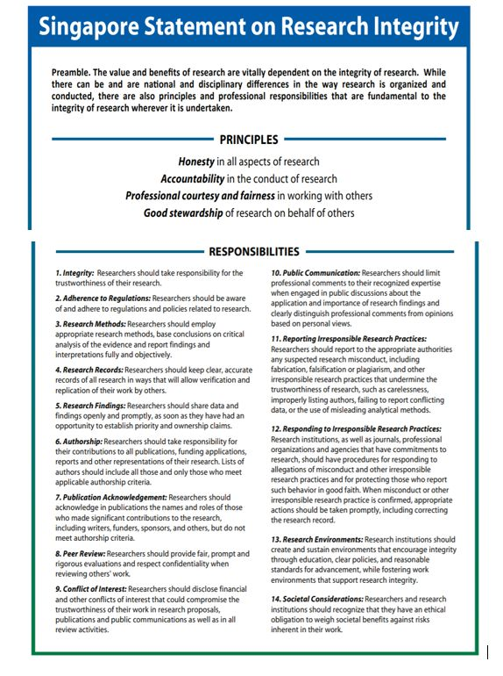

* TUT ethics (go through this link: <https://www.tut.ac.za/rni/rs/re/about> )

**EXAMPLE OF RESEARCHER JOURNEY – Ivankova case study**

